
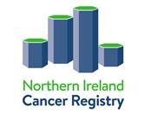

N. Ireland Cancer Registry Data Enquiry Form

Name and title of applicant: | Position:
Address: | Telephone:  Email:
Title of study:
Aim and purpose of studyª:

Details of information required (list each data item, appending additional pages if necessary)^{b}:

If there is a deadline for receipt of information, please give reason and date:

ª Please submit any associated study protocols, ethical agreements etc.
^{b} Do not include any identifiable patient information on this form

Please return the completed form to:
Information Governance, N.Ireland Cancer Registry, Centre for Public Health, Mulhouse Building, Grosvenor Road, Belfast, BT12 6DP Email: nicr@qub.ac.uk

